**SSA and EU free trade agreement - A sectoral analysis using GTAP model**

**Somesh K. Mathur1, Anuj Chauhan2**

**Summer Term - 20183**

***Abstract***

This paper develops a complete analysis of the effects of a free trade agreement between EU and SSA by using the GTAP model. It talks about how the shocks generated by free trade agreement will affect the different sectors such as Prices, Employment, TOT, Trade Balance, GDP etc in the economy of EU and SSA. RunGTAP software has been used to simulate the shocks for FTA between the regions. It uses a CGE(Computable General Equilibrium) model with a database provided by purdue university. Finally, the welfare (as a function of employment, tot, GDP) will be calculated to indicate that who will be gaining more from FTA. This paper would suggest that either EU should have an FTA with SSA or not.

***Table of Content***

***Sections***

1. Introduction
2. Literature Review
3. Simulation scenario - aggregation scheme and shocks to simulate FTA
4. Immediate effects of FTA - Prices and Demand in EU and SSA
5. Effects on Endowment demand - Land, Labour, Capital
6. Effects on Imports, Exports and Trade Balance
7. Effects on TOT
8. Changes in the GDP/Allocative Efficiency
9. Effect on Welfare - employment, tot, allocative efficiency.
10. Conclusion

***Tables***

1. Price index of Imports faced by EU
2. Demand of Imports in the EU
3. Price index of Imports in faced by SSA
4. Demand of Imports in the SSA
5. Effect on the Endowment demand by EU
6. Effect on Endowment demand by SSA
7. Effect on Imports (USD millions)
8. Effect on Exports by EU (USD millions)
9. Effect on Exports by SSA (USD millions)
10. Effect on Trade Balance (USD millions)
11. Effect on TOT (%age change)
12. Change in GDP (USD millions)
13. Change in Welfare = F(gdp, tot, emp)

***Charts***

1. Change in Imports of EU and SSA(USD millions)
2. Change in EU Exports (USD millions)
3. Change in SSA Exports (USD millions)
4. Change in Trade Balance of EU and SSA (USD millions)
5. Change in TOT (%age change)
6. Change in GDP (USD millions)
7. Change in welfare

**Introduction**

This paper analysis the effects of free trade agreement between EU and SSA using the GTAP model. GTAP model uses a CGE(Computable General Equilibrium) model which simulates the different countries/regions as having a common domestic structure of the economy. RunGTAP software is used for the simulation of FTA. We've used the version which is having 3X3 aggregated database having different countries aggregated into 3 regions. The three regions are EU (European Union), SSA (Sub Saharan Africa) and ROW (Rest Of the World). The different sectors are aggregated into 3 sectors. These three sectors are Food (agriculture and processed food products), Mnfcs (manufactured products), Svces (different services). An old version of GTAP is used in this paper due to the simplicity of performing experiments, but now there are newer versions also available like GTAPAgg (2008).

Section III describes Simulation Scenario i.e. Aggregation scheme and the shock that have been given to simulate the FTA. In the next section the immediate effect of shocks on prices and demand is discussed. In the next few section it is studied that how will a FTA affects the different sectors in the economy of EU and SSA. Many shocks are given to simulate the FTA like mutual elimination of import tariffs and export subsidies on all products and services. These shocks due to FTA are then studied to reach at a conclusion that is **either EU should have a FTA with SSA or not.**

**Literature Review**

***Welfare Implication of India-ASEAN FTA: An Analysis Using GTAP Model by Biswajit Nag***

***Aggregation scheme***- 20 regions, 35 sectors, 5 production factors.

***Experiments*** - Broadly two experiments was performed i.e. tariff elimination partially in perfect and imperfect competition and full liberalisation in perfect and imperfect competn.

***Results* -** The results concluded were that ASEAN will gain from TOT, India will have negative TOT and India will gain from changes in the prodn, Bigger ASEAN countries will gain more and at full liberalisation india’s welfare will be more than partial liberalisation.

**India-ASEAN Free Trade Agreement: A sectoral analysis by Shahid Ahmad**

***Aggregation scheme*** - 3 regions, 19 sectors, 5 production factors.

***Experiments*** - full liberalisation between India and ASEAN.

***Studied* -** Shahid studied the different sectors like effects on prices, welfare, output, imports, exports, employment.

***Results*** - The results concluded were that domestic prices in India will decrease and in ASEAN increases, TOT for India will decrease and for ASEAN will increase, net welfare of both the regions would increase, output/gdp of both the regions would increase, employment in both the region would also increase and also global imports of both increases and global exports of only India would increase.

**Simulation Scenario**

1. **Aggregation of countries into 3 regions**

In the RunGTAP software the version of GTAP used has aggregated data of all countries into 3 regions. The three regions are SSA, EU and ROW. Here are the underlying countries of different regions.

**SSA (Sub-Saharan Africa, inclusive of South Africa)**

Angola, Benin, Botswana, Burkina Faso, Burundi, Cameroon, Cape Verde, Central African Republic, Chad, Comoros, Congo (Brazzaville), Congo (Democratic Republic), Djibouti, Equatorial Guinea, Eritrea, Ethiopia, Gabon, The Gambia, Ghana, Guinea, Guinea-Bissau, Kenya, Lesotho, Liberia, Madagascar, Malawi, Mali, Mauritania, Mauritius, Mozambique, Namibia, Niger, Nigeria, Réunion, Rwanda, Sao Tome and Principe, Senegal, Seychelles, Sierra Leone, Somalia, South Africa, Sudan, Swaziland, Tanzania, Togo, Uganda, Western Sahara, Zambia, Zimbabwe.

**EU (European Union)**

Austria, Italy, Belgium, Latvia, Bulgaria, Lithuania, Croatia, Luxembourg, Cyprus, Malta, Czech Republic, Netherlands, Denmark, Poland, Estonia, Portugal, Finland, Romania, France, Slovakia, Germany, Slovenia, Greece, Spain, Hungary, Sweden, Ireland, United Kingdom.

**ROW (Rest of the World)**

Countries except EU and SSA having database.

1. **Aggregation of different sectors into 3 sectors**

In the RunGTAP software the version of GTAP used has aggregated data of all products and services into 3 sectors. The three sectors are Food, Mnfcs and Svces. Here are the underlying products and services of different sectors.

**Food (food and agriculture)**

Paddy rice, Wheat, Cereal grains, Vegetables, fruit, nuts, Oil seeds, Sugar cane, sugar beet, Plant-based fibers, Crops nec, Bovine cattle, sheep and goats, horses, Animal products, Raw milk Wool silk-worm cocoons, Bovine cattle, sheep and goat, horse meat prods, Meat products nec, Vegetable oils and fats, Dairy products, Processed rice, Sugar, Food products nec, Beverages and tobacco products

**Mnfcs (resources and manufactures)**

Forestry, Fishing, Coal, Oil, Gas, Minerals nec, Textiles, Wearing apparel, Leather products, Wood products, Paper products, publishing, Petroleum, coal products, Chemical, rubber, plastic products, Mineral products nec, Ferrous metals, Metals nec, Metal products, Motor vehicles and parts, Transport equipment nec, Electronic equipment, Machinery and equipment nec, Manufactures nec

**Svces (all services)**

Electricity, Gas manufacture, distribution, Water, Construction Trade, transport, Financial, business, recreational services, Public admin and defence, education, health, Dwellings & Svces

1. **Shocks to simulate Free Trade Agreement**

**4 shocks have been given to simulate Free trade agreement. Respective commands are also mentioned below.**

1) Elimination of tariffs by EU on imports from SSA on all sectors

Shock tms(TRAD_COMM,"SSA","EU") = select from file tms.shk ;

2) Elimination of export subsidies by EU on export to SSA on all sectors

Shock txs(TRAD_COMM,"EU","SSA") = select from file txs.shk;

3) Elimination of tariffs **by SSA on imports from EU on all sectors**

Shock tms(TRAD_COMM,"EU","SSA") = select from file tms.shk;

4) Elimination of export subsidies by SSA on export to EUon all sectors

Shock txs(TRAD_COMM,"SSA","EU") = select from file txs.shk;

**Immediate effects of FTA - Prices and Demand in the EU and SSA**

Due to elimination of mutual import tariff and export subsidies the prices of all sectors in both EU and SSA will be affected immediately and due to the change in the prices of commodities in the markets of EU and SSA, the demand of all commodities will be affected as seen in the tables.

**Price index of Imports in the EU**

pfm[**EU] is the price index of different sectors products used by different sectors in EU

|  |  |  |  |  |
| --- | --- | --- | --- | --- |
| pfm[**EU] | Food | Mnfcs | Svces | CGDS |
| Food | -0.86 | -0.86 | -0.86 | -0.86 |
| Mnfcs | -0.1 | -0.1 | -0.1 | -0.1 |
| Svces | -0.05 | -0.05 | -0.05 | -0.05 |

**Table I**

We can see that prices of all the products and services used by different sectors has gone down in EU

**Demand of Imports in the EU**

qfm[**EU] : is the demand of different sector products used by different sectors in EU

|  |  |  |  |  |
| --- | --- | --- | --- | --- |
| qfm[**EU] | Food | Mnfcs | Svces | CGDS |
| Food | 0.27 | 0.88 | 1.32 | 0.51 |
| Mnfcs | -0.91 | 0.17 | 0.03 | 0 |
| Svces | -1 | 0.09 | -0.06 | -0.08 |

**Table II**

We can see that demand of all the products and services used by different sectors has gone up in the EU ***but for some sectors it has gone down.***

**Price index of Imports in the SSA**

pfm[**SSA] is the price index of different sectors products used by different sectors in SSA

|  |  |  |  |  |
| --- | --- | --- | --- | --- |
| pfm[**SSA] | Food | Mnfcs | Svces | CGDS |
| Food | 8.81 | 8.81 | 8.81 | 8.81 |
| Mnfcs | -1.11 | -1.11 | -1.11 | -1.11 |
| Svces | -0.36 | -0.36 | -0.36 | -0.36 |

**Table III**

We can see that prices of all the products and services used by different sectors has gone down in SSA *but the prices of Food sector has gone drastically up which implies that EU must have been providing export subsidies to agriculture products before but as after the FTA now subsidies are eliminated because of that the food prices in SSA as imported from EU has gone up.*

**Demand of Imports in the SSA**

qfm[**SSA] : is the demand of different sector products used by different sectors in SSA

|  |  |  |  |  |
| --- | --- | --- | --- | --- |
| qfm[**SSA] | Food | Mnfcs | Svces | CGDS |
| Food | -0.11 | -9.93 | -7.9 | -7.28 |
| Mnfcs | 15.21 | 4.1 | 6.77 | 5.43 |
| Svces | 14.69 | 2.96 | 5.49 | 7.27 |

**Table IV**

We can see that demand of all the products and services used by different sectors has gone up in the EU *but in the food sector it has gone down because of elimination of export subsidies by EU.*

**Effects on Endowment demand - Land, Labour and Capital**

**Effect on the Endowment commodities demanded by EU**

qfe[**EU] : is the demand of endowments in EU due to change in the demand of imports by EU

|  |  |  |  |  |
| --- | --- | --- | --- | --- |
| qfe[**EU] | Food | Mnfcs | Svces | CGDS |
| Land | 0 | 0.95 | 0.96 | 0.81 |
| UnskLab | -0.97 | 0.18 | 0.04 | 0 |
| SkLab | -0.99 | 0.14 | -0.01 | -0.03 |
| Capital | -0.97 | 0.18 | 0.03 | -0.01 |
| NatRes | 0 | 0 | 0 | 0 |

**Table V**

Now as we know that the change in import demand of one region will directly affect the production in the other region so we can see that as Import demand of food by SSA has gone down due to which the demand for endowments gone down in the Food sector of EU, also mport demand of other P/S in SSA has gone up and due to which demand for endowments has gone up in the Markets of EU. So it is concluded that employment would be generated in Mnfcs and Svces sector but there will be unemployment in the Food sector in the EU.

**Total labour demand = adding all the cells in the given table = - 1.64**

|  |  |  |  |
| --- | --- | --- | --- |
| -0.97 | 0.18 | 0.04 | 0 |
| -0.99 | 0.14 | -0.01 | -0.03 |

**Table V.I**

**Effect on the Endowment commodities demanded by SSA**

qfe[**SSA] : is the demand of endowments in EU due to change in the demand of imports by SSA

|  |  |  |  |  |
| --- | --- | --- | --- | --- |
| qfe[**SSA] | Food | Mnfcs | Svces | CGDS |
| Land | 0 | -9.46 | -8.56 | -6.97 |
| UnskLab | 8.36 | -5.89 | -2.87 | -1.16 |
| SkLab | 9.78 | -3.52 | 0.11 | 1 |
| Capital | 9.64 | -3.77 | -0.2 | 0.78 |
| NatRes | 0.02 | 0 | 0 | 0 |

**Table VI**

As the Import demand of food by SSA has gone down due to the high prices of EU exports to SSA. So now SSA will be importing less from EU and because of that the domestic demand of Food products has to be fulfilled by the domestic markets and which will lead to a high endowment demand in the food sector in SSA and vice-versa in Mnfcs and Svces as Mnfcs and Svces products and services are imported more from EU after FTA due to decrease in prices.So it can be concluded that there will be employment generation in the Food sector in SSA and unemployment in the other sectors.

**Total labour demand = adding all the cells in the given table = + 7.2**

|  |  |  |  |
| --- | --- | --- | --- |
| 8.36 | -5.89 | -2.87 | -1.16 |
| 9.78 | -3.52 | 0.11 | 1 |

**Table VI.I**

**Effects on Imports, Exports and Trade Balance**

**Effect on Imports of EU, SSA and ROW**

As we have seen early that import demand of Food has gone down in SSA and because of that there will be less imports of Food by SSA from EU and vice versa for other sectors, Also imports demand of Food in EU has gone up due to which imports of EU has also gone up and similar for other sectors

|  |  |  |  |
| --- | --- | --- | --- |
| qim | SSA | EU | ROW |
| Food | -5.2806 | 0.9061 | -0.0792 |
| Mnfcs | 6.6116 | 0.0582 | -0.0283 |
| Svces | 6.5286 | -0.069 | -0.0421 |

**Table VII**

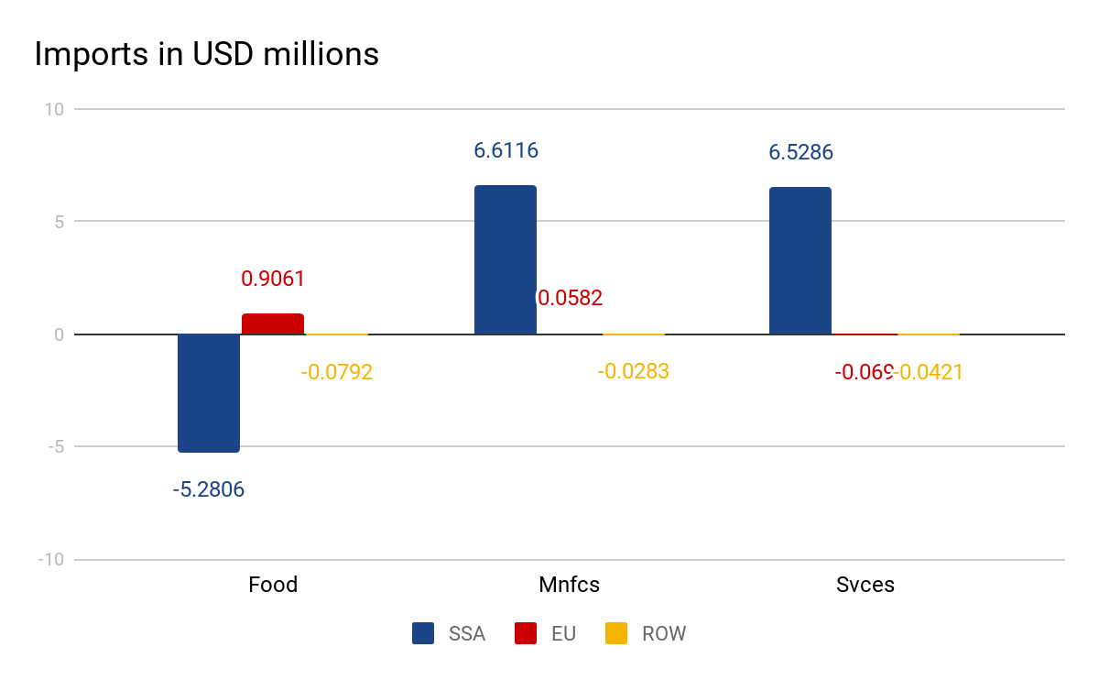

**Chart I**

**Effect on Exports by EU to SSA**

As the export subsidies are now eliminated due to which prices in the foreign markets shoot up and because of that the exports of Food products by EU has gone down, but in the markets of SSA the import prices of Mnfcs and Svces has gone up and because of that the exports of EU to SSA has increased in the Mnfcs and Svces sector.

|  |  |
| --- | --- |
| qxs[*EU*] | SSA |
| Food | -57.86 |
| Mnfcs | 16.49 |
| Svces | 8.59 |

**Tabel VIII**

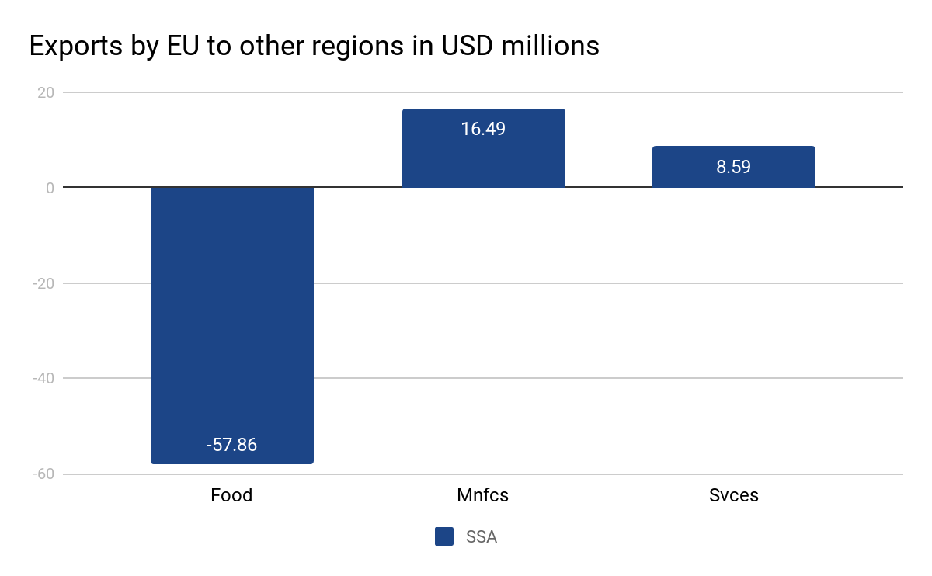

**Chart II**

**Effect on Exports by SSA to other regions**

It can be seen that the EU Food products are no more competitive in the EU markets because of that food exports by SSA has increased and vice versa for other sectors. **Trade diversion from ROW to EU can be seen clearly in the chart .**

|  |  |  |
| --- | --- | --- |
| qxs[*SSA*] | EU | ROW |
| Food | 83.26 | -18.12 |
| Mnfcs | 13.72 | -12.97 |
| Svces | -7.15 | -11.78 |

**Table IX**

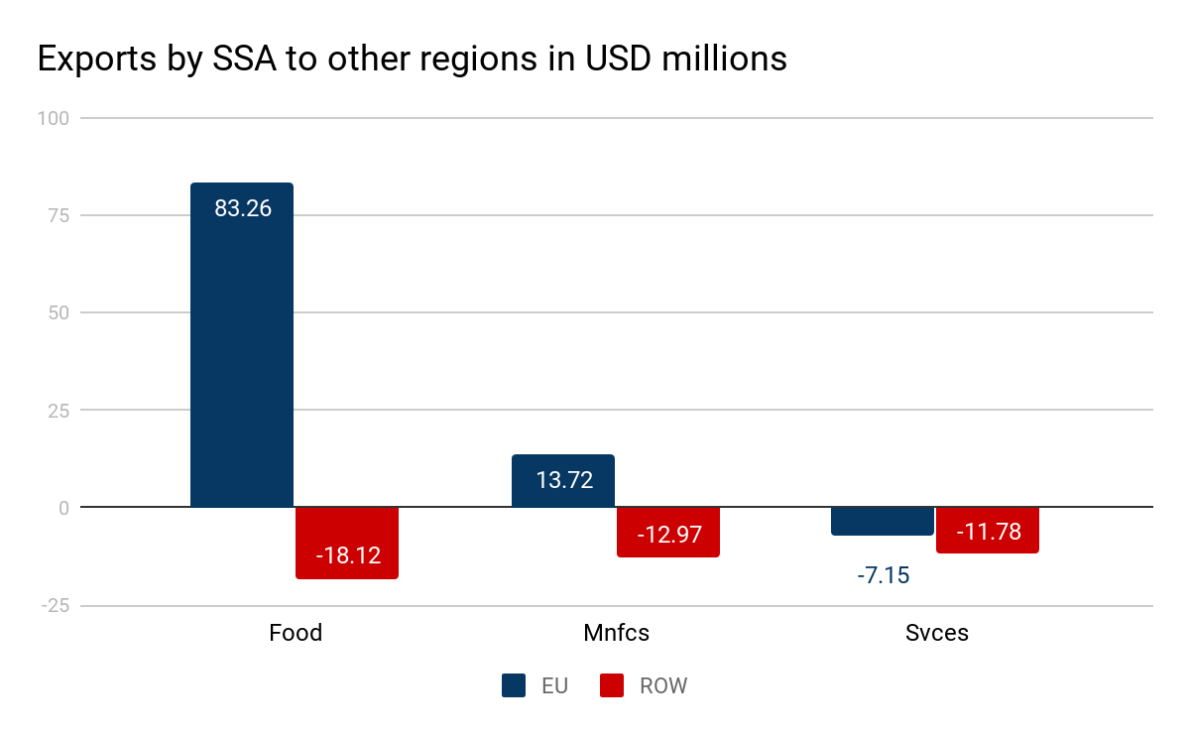

**Chart III**

**Effect on the Trade Balance**

The combined exports and imports of all sectors are shown here and it is concluded that EU would have a negative trade balance and SSA would have a positive trade balance

|  |  |
| --- | --- |
| DTBAL | (Sim) |
| SSA | 29.3086 |
| EU | -60.9765 |
| ROW | 31.668 |

**Table X**

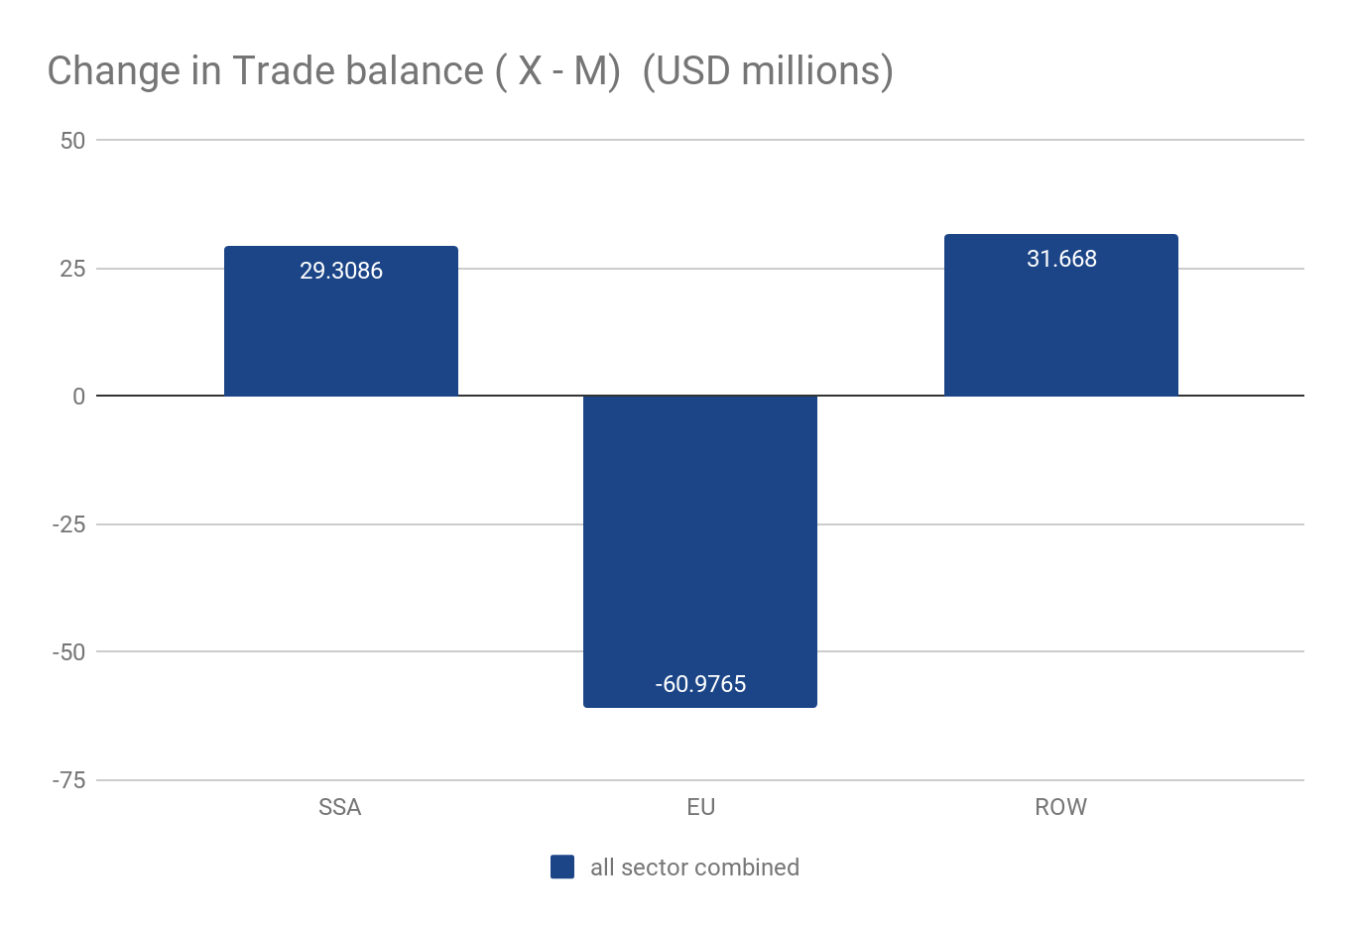

**Chart IV**

**Effect on TOT**

As we can see that SSA will gain in TOT by .8% and EU will have no effect on TOT

|  |  |  |  |
| --- | --- | --- | --- |
| Tot | Pre | Post | %Ch |
| SSA | 1 | 1.008 | 0.8 |
| EU | 1 | 1 | 0 |
| ROW | 1 | 0.9999 | -0.01 |

**Table XI**

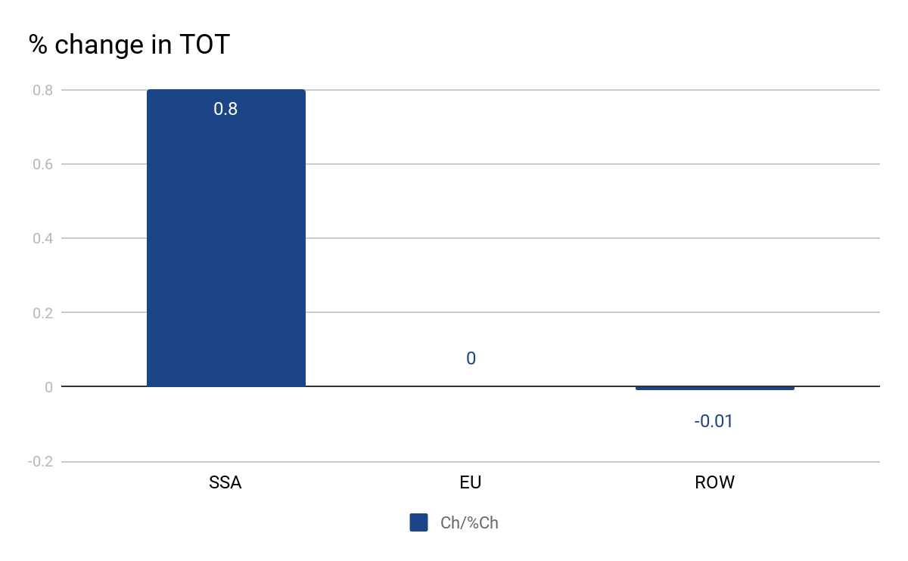

**Chart V**

**Changes in the GDP/Allocative Efficiency**

The increase in Export demand in SSA led to increase in production due to which employment has increased or gdp has also increased. A good indicator of Allocative efficiency is GDP and we can see that allocative efficiency in SSA has increased

|  |  |
| --- | --- |
| vgdp | Change |
| SSA | 3.3619 |
| EU | -0.1039 |
| ROW | -0.0283 |

**Chart VI**

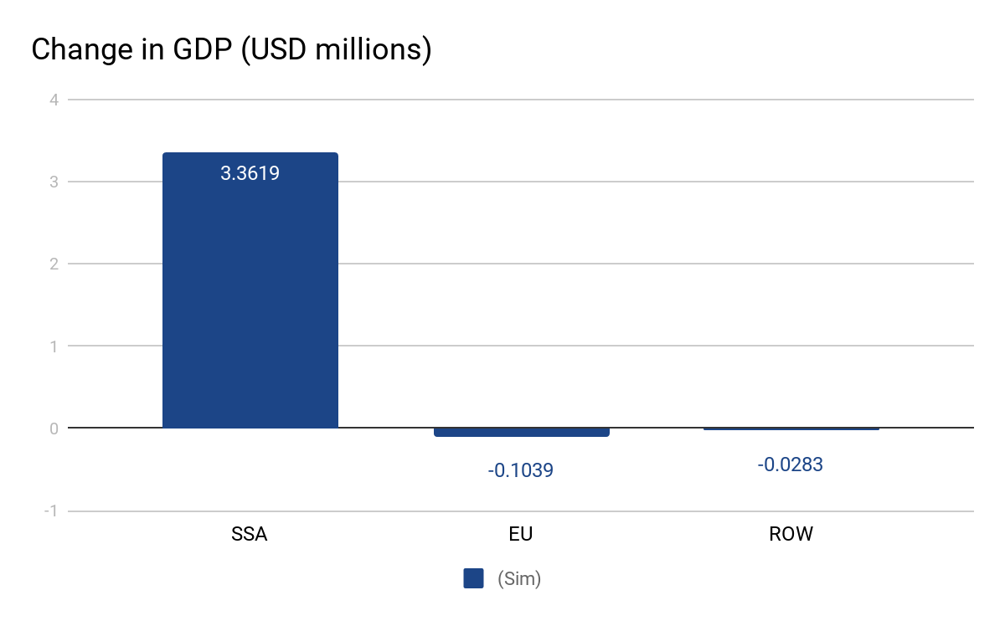

**Table XII**

**Effect on Welfare - Employment, TOT, allocative efficiency / GDP.**

It is clear that the welfare of SSA has increased but the EU’s welfare has gone down

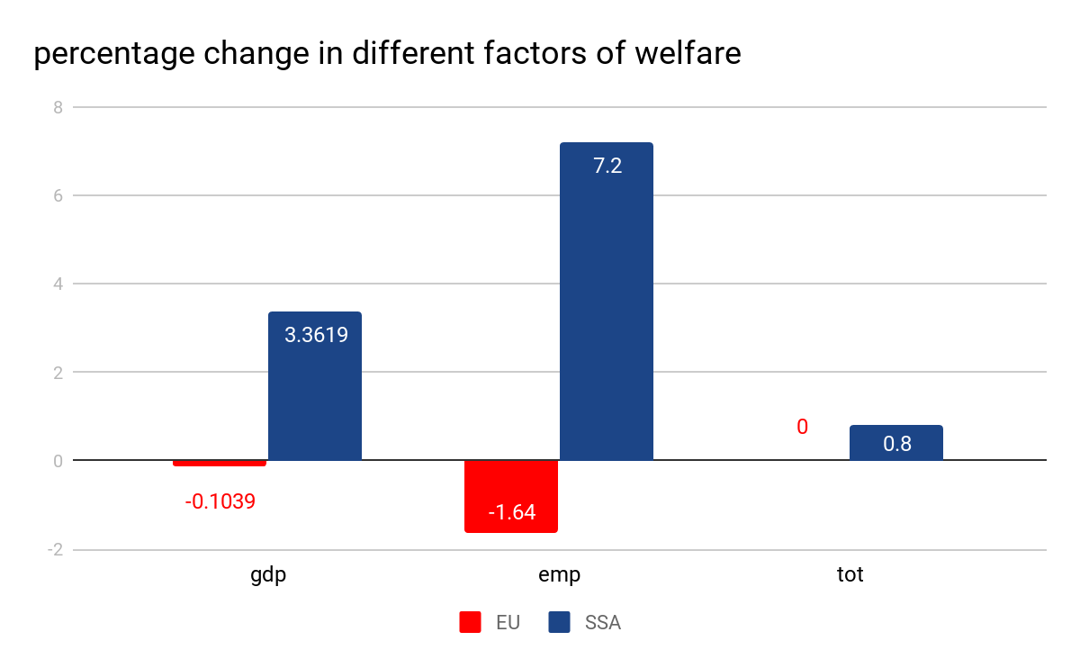

|  |  |  |
| --- | --- | --- |
| parameter | EU | SSA |
| gdp | -0.1039 | 3.3619 |
| tot | 0 | .008 |
| emp | -1.64 | 7.2 |

**Table XIII**

**Conclusion**

After analysing the significant aspects of FTA between EU and SSA it can be concluded that the welfare of SSA will be very positive from FTA but EU still have to face a negative welfare. So the suggestion to EU would be not to have a FTA with SSA.

***References***

*Nag, Biswajit and Sikdar, Chandrima, “Welfare Implication of India-ASEAN FTA: An Analysis Using GTAP Model (July 1, 2011)”, Indian Institute of Foreign Trade Working Paper No. EC-11-06.*

[*Tsung-Chen Lee*](https://www.inderscienceonline.com/author/Lee%2C+Tsung-Chen)*,* [*Paul T.W. Lee*](https://www.inderscienceonline.com/author/Lee%2C+Paul+TW)*, “South-South trade liberalisation and shipping geography: a case study on India, Brazil, and South Africa”,* [*International Journal of Shipping and Transport Logistics*](https://www.inderscienceonline.com/loi/ijstl)*,* [*Volume 4, Issue 4*](https://www.inderscienceonline.com/toc/ijstl/4/4)

*Ahmed, S.India-ASEAN Free Trade Agreement: A sectoral analysis, SSRN Working paper*

*1698849 (2010). Accessed November 2010. http://ssrn.com/abstract=1698849*

*Dash, P. K. (2010).‘India-ASEAN: Trade in goods agreement’,SME Times, 20 January 2010.New Delhi, India.*

*Huff, K. M. and T. W. Hertel (2000). “Decomposing welfare changes in the GTAP Model” , GTAP Technical Paper No. 5. Centre for Global Trade Analysis, Department of Agricultural Economics, Purdue University, Indiana, United States.*

*https://www.gtap.agecon.purdue.edu/resources/res_display.asp?RecordID=1638 - documentation*

*https://www.gtap.agecon.purdue.edu/resources/download/86.pdf - hertel*

*https://jgea.org/resources/jgea/ojs/index.php/jgea/article/view/47 - journal of economic analysis*

*https://www.gtap.agecon.purdue.edu/resources/download/185.pdf - welfare decomposition - important paper*

*https://www.gtap.agecon.purdue.edu/resources/download/2365.pdf - decomposition welfare changes*

*https://www.gtap.agecon.purdue.edu/resources/download/3601.pdf*